ISLAMIC UNIVERSITY OF TECHNOLOGY

Organization of Islamic Cooperation

Board Bazar, Gazipur

Performance Analysis  
of Job-Shop Model

CSE 4550

Muhammad Mahbub Alam

Imtiaj Ahmed Chowdhury

# Description

In this report, we present a comparison of the results of the output statistics derived from our Job-Shop Model simulations. The output statistics that were considered are:

* Average waiting delay, i.e. Queuing Delay
* Average number of jobs in the system, i.e. System Size
* Average server utilization

These values were calculated based on randomly generated arrival and departure times for 100 customers. The mean arrival time was assumed to be exponentially distributed at 10 time-units. The mean departure time (for the system) was assumed to be exponentially distributed and was varied between 4.75 to 9.25 time-units. For simplicity, the mean departure time for all servers have been considered to be equal.

There was a total of 5 workstations, each of which had a single queue and 3, 2, 4, 2 and 1 server respectively.

The order in which customers navigated the system was uniformly and randomly distributed as follows:

* Workstations 3, 1, 2 and finally 5, with a probability of 0.3.
* Workstations 4, 1 and finally 3, with a probability of 0.5.
* Workstations 2, 5, 1, 4 and finally 3, with a probability of 0.2.

# Simulation Results

## Collected Data

|  |  |  |  |  |  |
| --- | --- | --- | --- | --- | --- |
| **Arrival Mean** | **Departure Mean** | **Traffic Intensity** | **Average Queueing Delay** | **Average System Size** | **Average Server Utilization** |
| 10 | 4.75 | 0.475 | 10.0384 | 0.159986 | 0.142133 |
| 10 | 5 | 0.5 | 7.97402 | 0.159094 | 0.145273 |
| 10 | 5.25 | 0.525 | 6.22163 | 0.140305 | 0.129542 |
| 10 | 5.5 | 0.55 | 8.48025 | 0.173055 | 0.155331 |
| 10 | 5.75 | 0.575 | 45.7998 | 0.26596 | 0.192602 |
| 10 | 6 | 0.6 | 26.5527 | 0.23873 | 0.189504 |
| 10 | 6.25 | 0.625 | 19.6217 | 0.270292 | 0.226241 |
| 10 | 6.5 | 0.65 | 44.3474 | 0.24811 | 0.187148 |
| 10 | 6.75 | 0.675 | 27.8192 | 0.256047 | 0.21463 |
| 10 | 7.25 | 0.725 | 30.882 | 0.267193 | 0.198082 |
| 10 | 7.5 | 0.75 | 72.0206 | 0.329865 | 0.219407 |
| 10 | 8 | 0.8 | 36.3875 | 0.289463 | 0.227572 |
| 10 | 8.25 | 0.825 | 102.535 | 0.395864 | 0.244896 |
| 10 | 8.5 | 0.85 | 83.9238 | 0.412491 | 0.275741 |
| 10 | 8.75 | 0.875 | 60.3558 | 0.421864 | 0.307004 |
| 10 | 9 | 0.9 | 41.6473 | 0.327609 | 0.251815 |
| 10 | 9.25 | 0.925 | 171.521 | 0.464903 | 0.262443 |

## Average Queuing Delay



The average queueing delay seems to increase as traffic intensity increases. This makes sense, since the lower the difference between how often customers arrive and how often they depart, the more likely it is that a customer will have to wait in the queue for longer.

## Average System Size

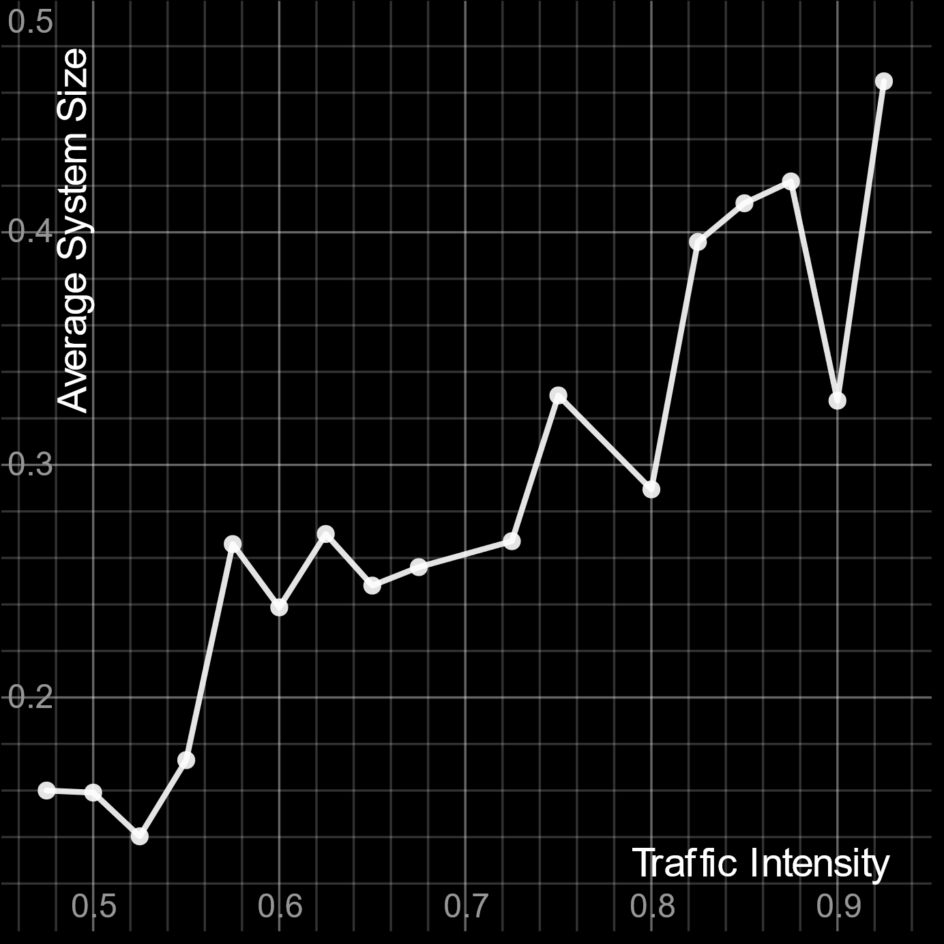

The system size tends to go up as traffic intensity increases. This is in line with the definition of traffic intensity, which is the average occupancy of a system.

## Average Server Utilization

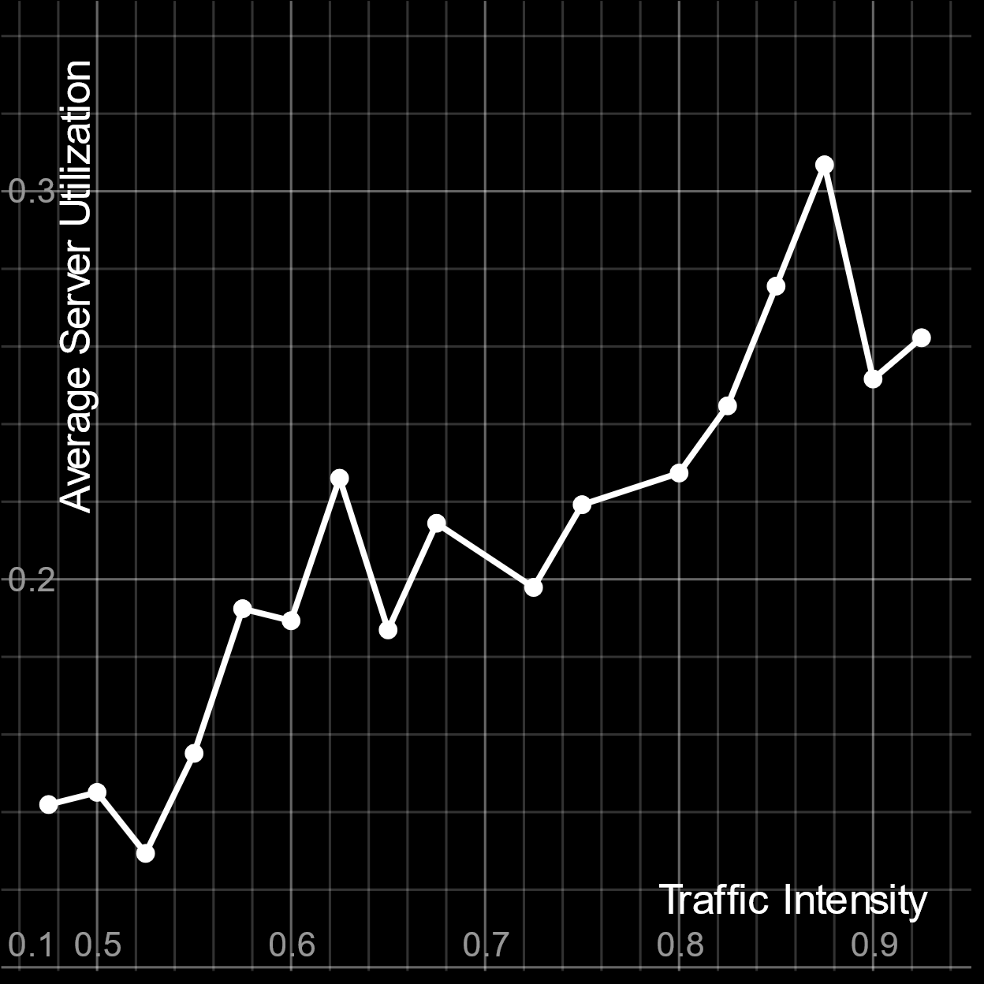

The average server utilization tends to increase as traffic intensity increase. If there are a higher number of customers in the system, it becomes less likely that a particular server will remain idle.